Wake Forest grading rubric and bins
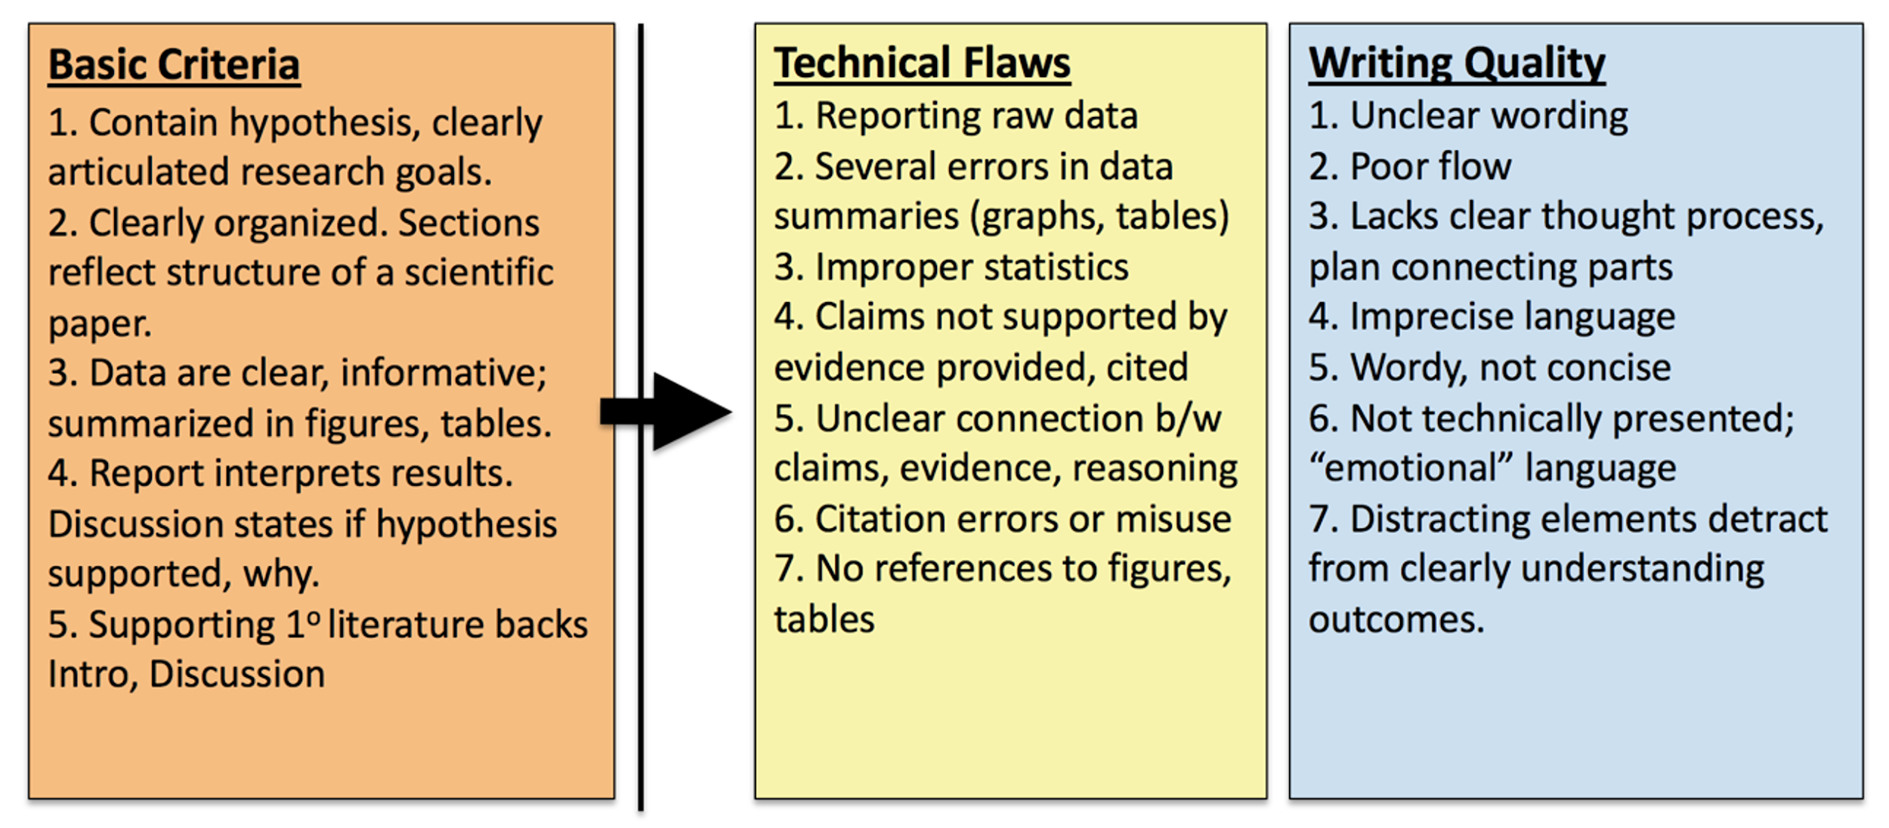
Submitted | Criteria | Bin  Score | Equivalent %
No | Not submitted; plagiarized | 0 | 0%
Yes | Fails to meet 1+ basic criteria (max. score on revision = 3) | 1 | 55%
Yes | Meets 5 basic criteria; both technical and writing flaws | 2 | 75%
Yes | Meets 5 basic criteria; either technical or writing flaws | 3 | 85%
Yes | Meets 5 basic criteria; no major technical or writing flaws | 4 | 95%

Washington College grading checklist and bins
Title: Title uses the format “The Effect of (Independent Variables) on (Dependent Variable) in (Organism or system), capitalize all words except a/of/the
Introduction
- Includes brief overview of biology concepts from Campbell textbook and/or lab manual to provide context for experiment
- Includes information about variable from research summary
- Experiment-specific prediction stated
- 1 sentence summary of techniques or methods used
- Intro is structured like an upside-down triangle; information flows from general to specific
Materials and Methods
- Completely written in past tense and in your own words
- Lab manual is cited appropriately
- Describes the experimental setup, materials, and equipment in sufficient detail, including any specialized tools used

Results
- Contains a paragraph of text that compares results using percentages, but does not explain why the results happened.
- Figures are referred to in the text like this (Figure 1).
- Figure properly formatted, no gridlines, axes present and labeled, appropriate data, * on significant p-value(s)
- Figure legend-Title “The effect of (independent variable) on (dependent variable) in (organism)”; has number of replicates and figure number; legend below figure
Discussion
- Each result is explained fully and separately in comparison to control(s) and each other. Figures are referred to in the text like this (Figure 1).
- Explanation of results is based on correct biological principles and reasoning
- Experimental weaknesses are discussed in 1-2 sentences and solutions are suggested.
- Author concludes by suggesting applications or implications of this research (why should we care?)
- Discussion structured like a triangle; information flows from specific to general
Literature cited
- The required number of references used and they use proper APA format. (Textbook and lab manual)
- In-text citations used in the correct context and properly formatted (APA name-year)
Writing: Typos, misspellings, grammar and usage errors minimized

Submitted | Criteria | Rough draft score | Final draft score %
No | Not submitted or plagiarized | 0 | 0%
Yes | Major missing part(s), basic criteria not met | 1 | 55%
Yes | Major or pervasive flaws in technical and/or writing quality | 2 | 75%
Yes | Some flaws in technical and/or writing quality | 3 | 85%
Yes | Satisfactory, a few minor problems | 4 | 95%
Yes | Ready for publication | Not available | 100%

